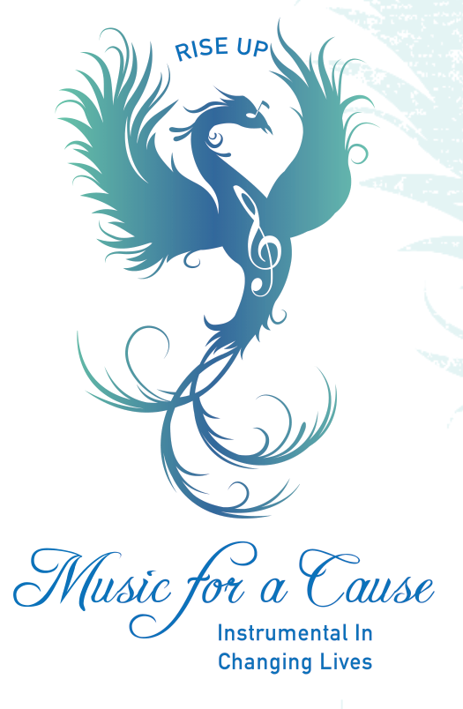

Addiction and Family Recovery
  - An educational resource guide for Music For A Cause
For community events, family conversations, volunteer education and recovery awareness. Prepared October 30, 2026.
Addiction can affect health, relationships, financial security and daily life. Effective care and practical family support can help people recover. This guide explains substance use disorders, alcohol and opioid risks, problematic pornography use, gambling disorder and the responsible use of death statistics.

Understanding addiction
Substance use disorder is a health condition involving harmful patterns of substance use. Addiction commonly refers to its more severe forms. Changes in reward, learning and self-control can make stopping difficult. Risk reflects multiple influences, including biology, environment, stress and trauma; no single family type or personal characteristic explains it. [1]
- Possible signs include repeated difficulty cutting down, strong urges and continued use despite harm. A qualified clinician should assess the pattern and severity.
- Use respectful language such as “person with a substance use disorder.” Avoid labels that reduce someone to a problem.
- Recovery may include medical care, counseling, medication, peer support and practical help. Faith communities can offer connection alongside professional care.
Educational use only. This guide does not diagnose or replace individual care. For an unresponsive person, abnormal breathing, seizures or immediate danger, call 911.

Educational materials
[1] CDC Understanding Addiction to Support Recovery

How addiction affects the family
The impact can extend to partners, children, parents, siblings and caregivers. Stress and disrupted routines can affect the whole household. Family support may help treatment, and relatives deserve support for their own well-being even if their loved one is not ready for change. [2, 3]

What families may experience
- Emotional strain: worry, anger, grief, shame or feeling constantly on alert.
- Relationship strain: secrecy, broken agreements and difficulty rebuilding trust.
- Practical strain: missed work, caregiving demands, bills and uncertainty about housing or transport.
- Effects on children: fear, confusion and taking on adult responsibilities. Explain in age-appropriate terms that the child did not cause the problem and is not responsible for fixing it.

Practical steps for family recovery
- Speak when the person is sober and the setting is calm. Describe specific observations and offer help finding an assessment.
- Set clear boundaries around safety, money and responsibilities. A boundary describes what you will do; it cannot force recovery.
- Protect children and vulnerable adults. Seek urgent help for threats or violence.
- Consider family counseling, family peer support and an individual support plan. Attend to sleep, health, friendships and finances.
- Recognize progress while rebuilding trust through consistent behavior over time. Family healing may take longer than stopping the behavior.

Suggested MFAC discussion
Question: What is one way to support a loved one without neglecting yourself? Example response: “I can help arrange an appointment while keeping money for rent and getting counseling for myself.” This is an illustration, not a prescription for every household.

Educational materials
[2] SAMHSA Helping Families Cope
[3] SAMHSA Navigating Mental Health and Substance Use Care downloadable family guide

Alcohol use disorder and alcoholism
Alcohol use disorder, or AUD, is the clinical term for difficulty controlling alcohol use despite harm. “Alcoholism” is a commonly used term. A person can have AUD while still working and maintaining outward routines. Assessment considers the pattern and consequences, not stereotypes. [4]

Signs that warrant an assessment
- Drinking more or longer than intended; repeated unsuccessful efforts to reduce drinking.
- Cravings or drinking that interferes with home, school, work or relationships.
- Continuing despite health or emotional problems; needing more alcohol for the same effect; withdrawal symptoms.

Treatment and recovery
Options include behavioral treatment, mutual-support groups and medications. Naltrexone, acamprosate and disulfiram are FDA-approved treatments for AUD. A clinician helps select care according to the person’s health, goals and preferences. Many people recover, although setbacks can occur. [4]
Stopping suddenly after prolonged heavy drinking can cause life-threatening withdrawal. Seek medical advice before attempting to stop when dependence is possible. Seizures, severe confusion or other emergency symptoms require urgent medical attention. [4]

Recognizing alcohol overdose
Warning signs include inability to wake up, confusion, vomiting, seizures and slow or irregular breathing. Call 911 immediately. Stay with the person and follow dispatcher instructions. Do not assume they can sleep it off; coffee, cold showers and walking do not reverse overdose. [5]

Suggested MFAC discussion
Question: Why might a person delay asking for help? Example answers include fear of judgment, concern about employment and believing that having a job means drinking cannot be a problem.

Educational materials
[4] NIAAA Understanding Alcohol Use Disorder educational handout
[5] NIAAA Understanding the Dangers of Alcohol Overdose

Opioid use disorder and overdose prevention
Opioids include certain prescription pain medicines, heroin and fentanyl. Opioid use disorder, or OUD, involves a harmful pattern of use and is treatable. Physical dependence can occur with prescribed use and is not, by itself, the same as addiction. Illicit fentanyl may be present in counterfeit pills or other drugs without the person knowing. [6]

Treatment that supports recovery
Buprenorphine, methadone and naltrexone are FDA-approved medications for OUD. Medication treatment is associated with reduced overdose and mortality risk. Detoxification alone is not recommended for OUD because returning to use can carry increased overdose risk. Counseling and recovery support can help, but lack of counseling should not delay medication treatment. [7]

Recognize a possible overdose
- The person cannot be awakened.
- Breathing is very slow, irregular or absent; there may be gurgling sounds.
- Lips or nails may change color; pupils may be very small. Do not wait for every sign. [6]

Respond immediately
Give naloxone if available and call 911 immediately. Follow the product instructions and dispatcher guidance for rescue breathing or CPR. If normal breathing has not returned after 2 to 3 minutes, give another dose according to the product instructions. If breathing independently, place the person on their side. Stay until emergency services arrive, even if the person wakes up. [8]
Families can obtain naloxone and learn how to use it. Naloxone reverses opioid overdose temporarily; it does not replace emergency care or ongoing treatment. [8]

Educational materials
[6] NIH Opioids overview and emergency information
[7] CDC Treating Opioid Use Disorder
[8] CDC Five Things to Know About Naloxone

Problematic pornography use
People sometimes use “porn addiction” to describe pornography use they feel unable to control. Clinically, problematic pornography use may occur within compulsive sexual behavior disorder, or CSBD. WHO classifies CSBD as an impulse control disorder. It is not a separate pornography addiction diagnosis in the DSM-5-TR. [9, 10]

Distinguishing concern from a disorder
Assessment focuses on persistent loss of control and significant impairment or distress. Frequency of use, strong sexual interest or moral disapproval alone does not establish CSBD. A person can seek counseling for distress or relationship concerns without having an addiction diagnosis. A clinician should also consider other explanations, including mood conditions and medication effects. [11]

Possible harms and family impact
When behavior becomes compulsive, it may displace responsibilities, involve secrecy or spending, and damage trust. Partners may experience distress and need their own support. Do not assume every pornography user experiences these harms, and do not equate pornography use with sexual offending. [9]

Care and support
A qualified mental health professional can assess the situation. Care may include cognitive behavioral therapy, other psychotherapy and treatment of co-occurring conditions. Partners or couples may benefit from counseling when appropriate and safe. Recovery planning can address triggers, coping skills and mutually agreed boundaries. [10]

Suggested MFAC discussion
Question: How can we discuss a private struggle without increasing shame? Example response: “Speak privately, describe the actual impact, and offer confidential professional support rather than assigning a label.” Avoid asking attendees for personal disclosures.

Educational materials
[9] Mayo Clinic Compulsive Sexual Behavior symptoms and causes
[10] Mayo Clinic Diagnosis and Treatment
[11] World Psychiatry Compulsive Sexual Behaviour Disorder in the ICD 11

Gambling disorder
Gambling disorder is a recognized behavioral addiction. Harm can occur through sports betting, online gambling, casinos or other betting. The concern is impaired control and harmful consequences; the dollar amount alone does not determine whether someone has a disorder. [12]

Warning signs
- Repeatedly trying and failing to stop or reduce gambling.
- Increasing bets, preoccupation with betting or returning to win back losses.
- Hiding gambling, borrowing money or jeopardizing relationships and responsibilities. [12]

How the household can be affected
Hidden debts and broken agreements can undermine financial security and trust. Family members may need support and help protecting essential household funds. Children should receive age-appropriate explanations without being made responsible for monitoring an adult. [13]

Treatment and practical support
Therapy, including cognitive behavioral and family approaches, can help. There is no FDA-approved medication specifically for gambling disorder; clinicians can address co-occurring conditions. Family members may benefit from Gam-Anon, while Gamblers Anonymous offers peer support to people who gamble. Peer groups complement professional care. [12, 13]
Agree on financial safeguards, seek qualified advice about debt and ask a gambling counselor about self-exclusion or other access controls. Avoid treating another bet as a solution to losses. Severe financial distress or suicidal statements require an urgent response; immediate danger warrants 911.

Suggested MFAC discussion
Question: Why can gambling remain hidden? Example answers include private phone access, hidden transactions and fear of admitting losses. For an inclusive recovery event, consider donation appeals instead of betting-themed activities.

Educational materials
[12] American Psychiatric Association Gambling Disorder
[13] American Psychiatric Association What Is Gambling Disorder
[14] National Council on Problem Gambling Rhode Island resources

Deaths related to substance use and addiction
Deaths may involve overdose, alcohol-related disease or injury, and other pathways. There is no single count that captures every death attributable to addiction. These figures describe different populations and periods; they must not be added together.

National and Rhode Island figures
Measure | Figure and period | Meaning
United States drug overdose deaths | 79,384 in 2024 | Final CDC count across drug types and intents. Not limited to opioid deaths or people diagnosed with addiction. [15]
United States deaths from excessive alcohol use | About 178,000 per year during 2020 and 2021 | Estimated annual average, including disease and injury. Not a 2026 count or a count only among people with AUD. [16]
Rhode Island accidental overdose deaths | 329 in 2024 | RIDOH reported an 18.6% decline from 2023. State accidental overdose definitions differ from the national all-intent measure. [17]

Use these numbers responsibly
Alcohol and drug deaths can overlap when more than one substance is involved. Overdose can occur without a diagnosed disorder. Gambling-related suicide risk is a serious concern, but the sources here do not establish a reliable annual United States death total caused by gambling. They also do not establish a pornography addiction death count. Do not invent totals or attribute all suicides to addiction.

Educational materials
[15] CDC Drug Overdose Deaths in the United States 2023 to 2024
[16] NIAAA Alcohol Related Emergencies and Deaths
[17] RIDOH June 12 2025 release Rhode Island overdose decline

Using the materials and finding support

Suggested MFAC education session
A 30-minute format: 5 minutes on addiction and stigma; 8 minutes on family impact; 7 minutes on the relevant topic; 5 minutes on overdose awareness when appropriate; and 5 minutes for questions and private resource referrals. Invite a licensed clinician or qualified recovery educator to help answer clinical questions.
- Use the linked handouts for an event resource table or family education packet. The summaries in this guide are original educational explanations, not reproductions of entire publications.
- Ask permission before sharing a personal story. Allow people to pass on questions and avoid pressuring anyone to disclose a diagnosis, trauma or sexual history.
- Link to original publications and check their reuse terms before reprinting or altering them. Do not imply MFAC is endorsed by the source organizations.
- Refresh statistics, contact information and links before the March 2027 fundraiser. Clinical information and service availability can change.

Treatment and family support
FindTreatment.gov search United States treatment services
SAMHSA family guide practical navigation and whole family support
Rhode Island treatment recovery and overdose prevention resources
Rhode Island gambling help treatment and family support directory
The Rhode Island gambling directory lists the Rhode Island Council on Problem Gambling at 401-354-2877. SAMHSA lists its treatment referral helpline at 1-800-662-HELP (4357). These are resource and referral contacts, not substitutes for emergency services. [2, 14]

About Music For A Cause
MFAC uses music events and guest speakers to increase awareness and education about addiction, encourage recovery, and raise support for organizations serving individuals and families.
Kevin Ethier | 401-862-1871
kethier@ienrollsolutions.com
Sources were checked October 30, 2026. Bracketed source numbers connect each section to its linked educational materials. Figures retain their original reporting years.

